LUDO BOARD USING PYTHON TURTLE

Name: Abhishek Unnikrishnan

Course: MCA 2025-27

**AIM:**

The project focuses on designing the layout of a ludo board using basic logical movement of turtle in different coordinate positions. It enhances our programming skills by applying concepts of graphics, logic building and user interaction.

**APPROACH:**

* The turtle screen is initialized with a fixed size (**setup()**) and pen settings (**speed(), pensize(), hideturtle()**).
* Four large squares are drawn and filled with colours (**yellow, blue, red, green**) to represent the Ludo houses.
* Triangles of different colours are drawn inside the middle square to form the Ludo star.
* Circles filled with white are drawn inside each house to represent token positions.
* Grids are drawn using functions (**draw_grid1, draw_grid2, draw_grid3, draw_grid4**) to form the movement paths for tokens.
* Entry paths for each player are drawn in their respective colours to show the winning route.

**SCREENSHOT:**

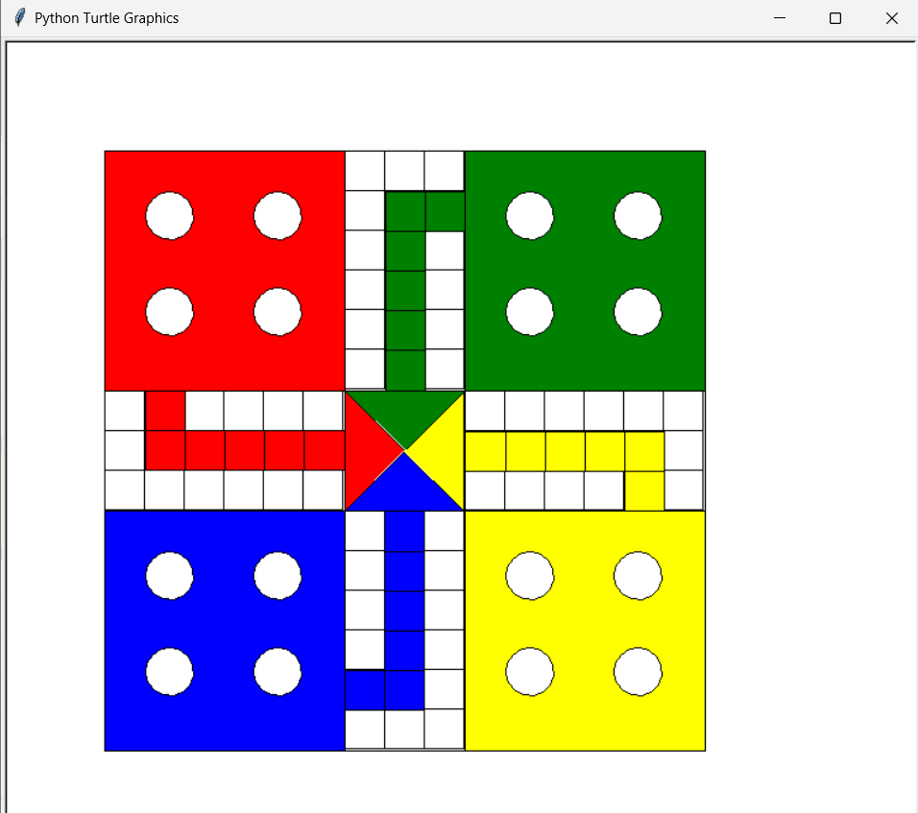

**CHALLENGES:**

* Incorporating the self-created Ludo board image into Python and aligning token positions accurately was complex and required careful mapping of coordinates.
* Debugging issues like invalid moves, overlapping tokens, and program crashes demanded detailed testing and validation.

**LEARNINGS:**

* Gained hands-on experience in **Python graphics programming** by integrating custom images and aligning gameplay elements.
* Gained enhanced knowledge of **event-driven programming** and user interaction in Python.
* Developed patience and precision in **debugging, testing, and refining** the project to achieve smooth functionality.